Southern Oregon ESD (SOESD) contracted Carruth Compliance Consulting, Inc. (CCC) in May of 2014 to assist with administration of SOESD’s 403(b) Tax Sheltered Annuity 403(b) Plan (“TSA Plan”). The TSA Plan is designed for retirement savings to supplement retirement income from PERS and Social Security.
The welcoming announcement distributed to SOESD employees in May of 2014 pointed employees to the SOESD home page of the CCC website at:
www.ncompliance.com/guest_employees.aspx?EmployerID=132
The May 2014 announcement pointed out that important features of the TSA Plan appear in the ‘Southern Oregon ESD Employee Menu’ box, including:
- List of Vendors
- Plan Document
- Enrollment Procedures
- Salary Reduction Agreement (“SRA”)
- Frequently Asked Questions
All employees are eligible to contribute to the TSA Plan. You may begin participating in the TSA Plan at any time, by first establishing an investment account with a participating vendor, and then completing a SRA. SOESD allows you to submit SRAs to manage contribution elections online. Basic instructions for submitting SRAs are available on the SOESD home page, but this document is designed to provide detailed step-by-step instructions for doing so if you prefer not to create an employee login user.
Important Note: You must have established an account with any participating investment company (vendor) you select before submitting an SRA involving contributions to that investment company (vendor).
Please contact CCC if you have any difficulty submitting an SOESD TSA Plan SRA, or if you have any other questions about the SOESD TSA Plan.
Carruth Compliance Consulting, Inc. 11515 SW Durham Road, Suite E-10
E-mail: cccinfo@ncompliance.com Tigard, OR 97224
Phone: 503-968-8961 / 877-222-3090 Fax: 503-968-7802 / 503-598-8441
For employees who prefer not to create an employee login user account, yet want to submit an SRA to replace/override a previous SRA, start/initiate a very first SRA, or cancel/discontinue an existing SRA.
Screen 1
Web Address (URL): https://www.ncompliance.com/guest_employersra.aspx?employerid=132
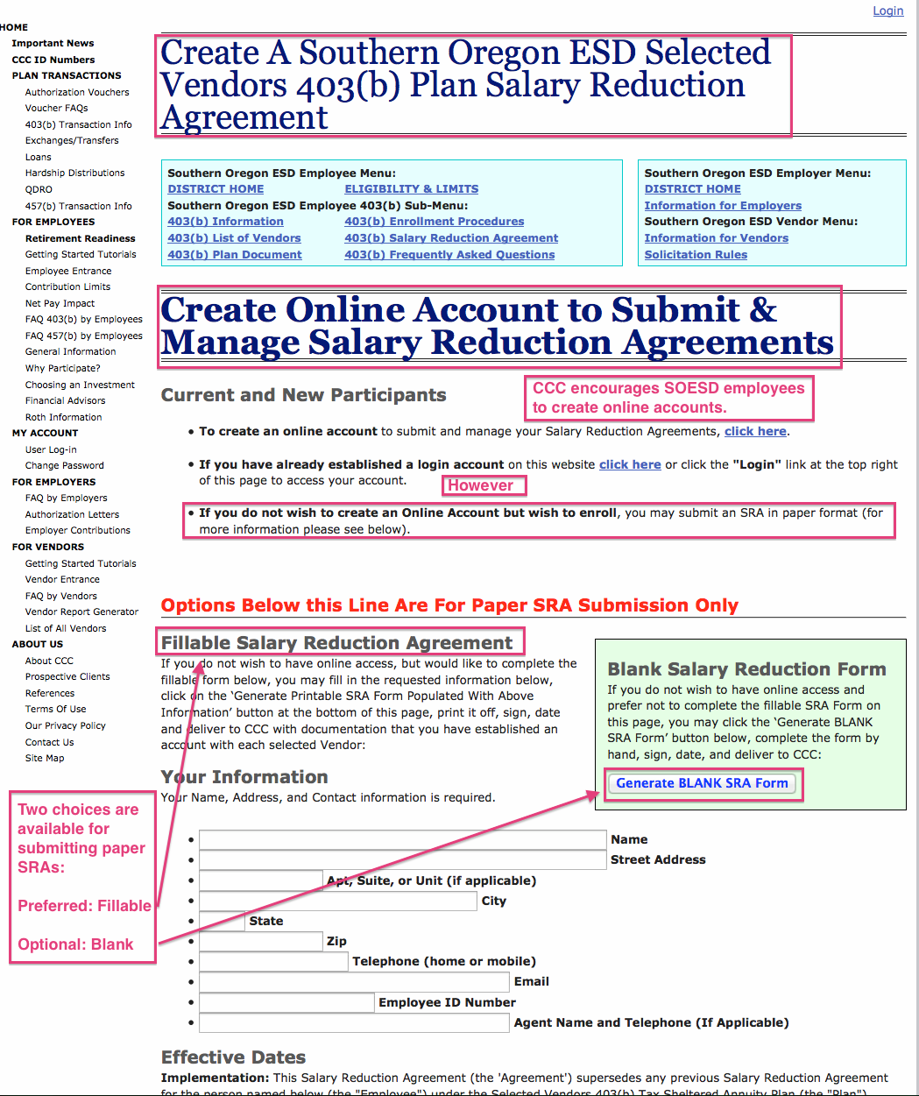
Screen 2 (Use of Fillable Form to Generate Paper SRA Form)
Web Address (URL): https://www.ncompliance.com/guest_employersra.aspx?employerid=132
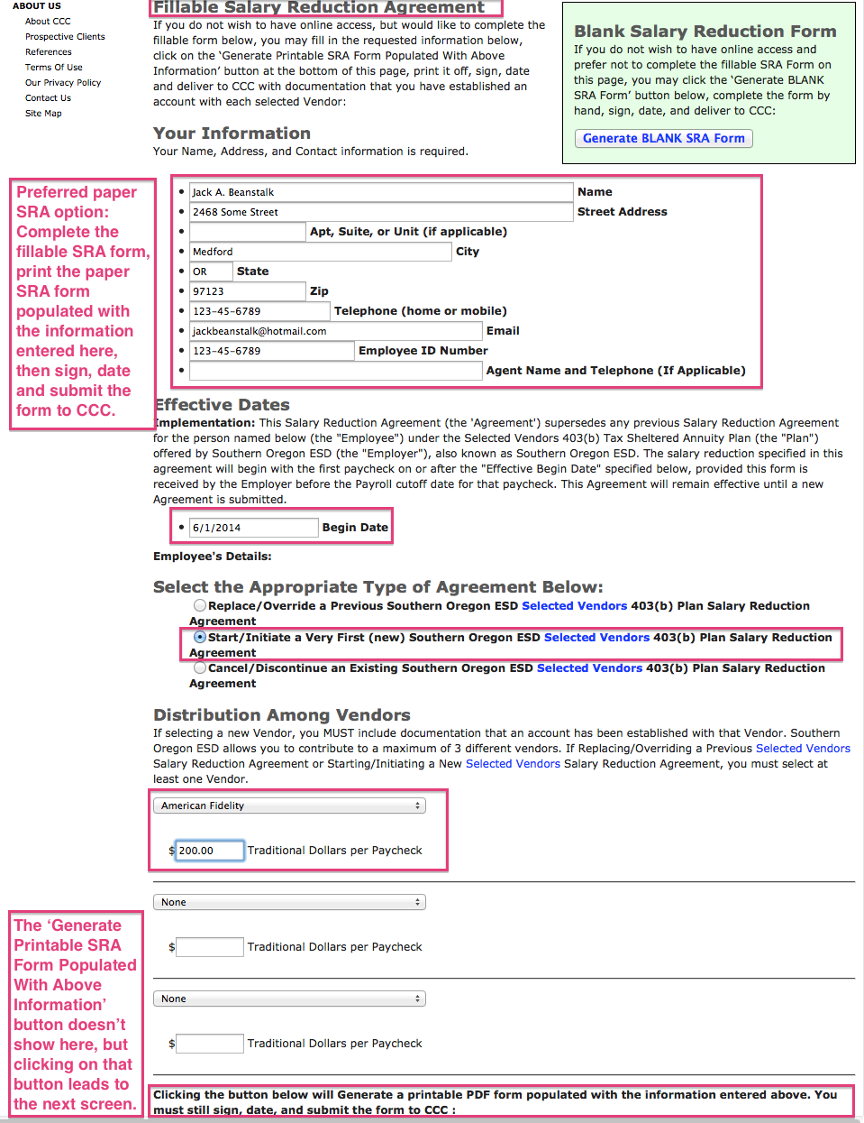
Screen 3 (Use of Fillable Form to Generate Paper SRA Form)
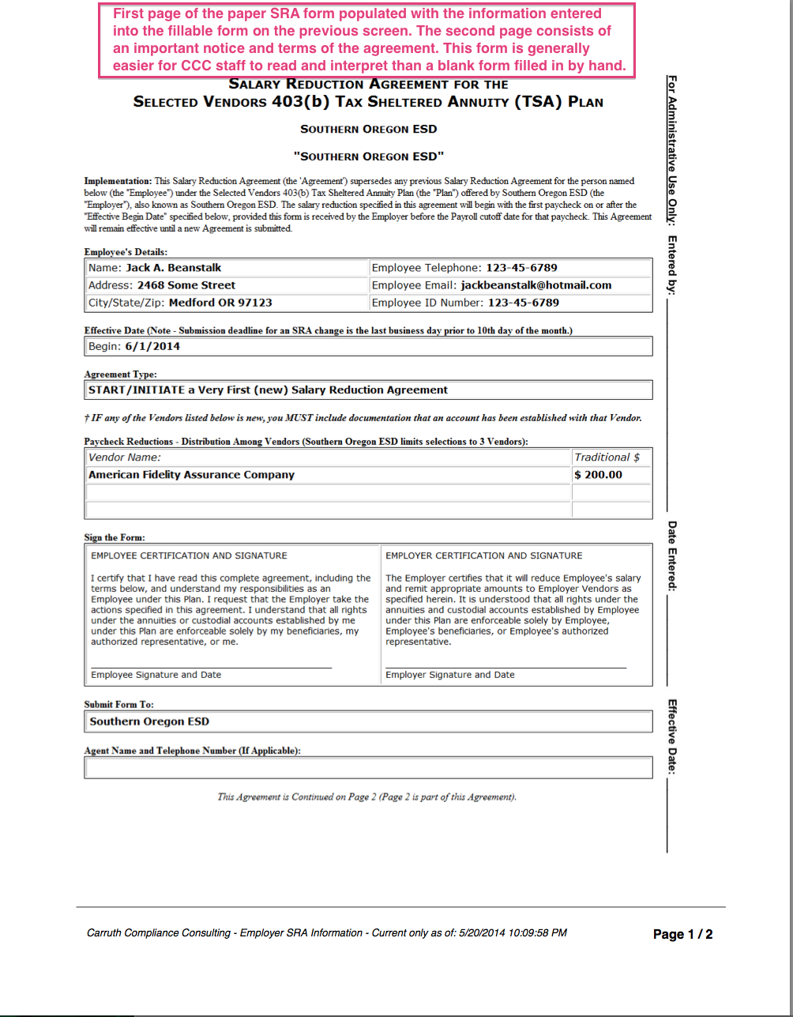
Screen 4 (Use of Blank Form to Complete By Hand)
